BMV:BIMBO A (MI KEY: 4276592; SPCIQ KEY: 877906)

View Security: | Summary
Selected Tabs: | All

Summary

Ownership Summary

Type | Common Stock Equivalent Held | Percent of Common Shares Outstanding (%) | Market Value (Mex$M)
Institutions | 236,048,640 | 5.49 | 13,079.5
Public and Other | 4,060,235,575 | 94.51 | 224,977.7
Total | 4,296,284,215 | 100.00 | 238,057.1

Float Summary

Grupo Bimbo S.A.B. de CV
Standardized Data
Oct-06-2026
= Total Shares Excluded From Float | 0
Free Float Shares | 4,296,284,215
/ Shares outstanding | 4,296,284,215
= Float%

Summary: Percent of Common Shares Outstanding (%)

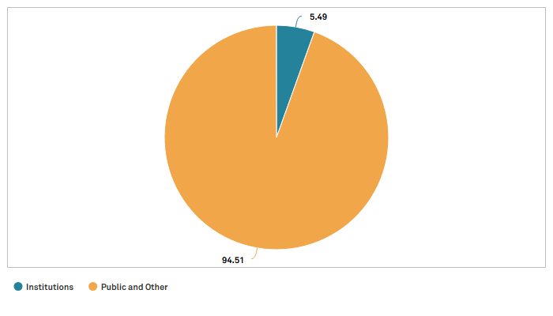

Top Holders

Top Holders

Holder | Common Stock Equivalent Held | Percent of Common Shares Outstanding (%) | Market Value (Mex$M) | Position Date | Institution is an Activist?
BlackRock Inc. | 104,120,971 | 2.42 | 5,769.3 | 9/30/2026 | No
Vanguard Capital Management LLC | 50,654,024 | 1.18 | 2,806.7 | 8/31/2026 | No
Dimensional Fund Advisors LP | 11,755,209 | 0.27 | 651.4 | 8/31/2026 | No
Geode Capital Management LLC | 6,721,307 | 0.16 | 372.4 | 7/31/2026 | No
Charles Schwab Investment Management Inc. | 5,233,843 | 0.12 | 290.0 | 8/31/2026 | No

Current Top Holders Activity

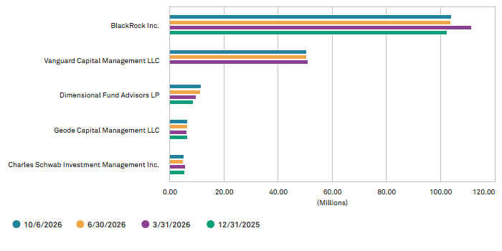

Top Mutual Fund Holders

Top Mutual Fund Holders

Holder | Common Stock Equivalent Held | Percent of Common Shares Outstanding (%) | Market Value (Mex$M) | Position Date
iShares NAFTRAC | 39,019,798 | 0.91 | 2,162.1 | 8/31/2026
Vanguard STAR Funds - Vanguard Total International Stock ETF | 17,381,900 | 0.40 | 963.1 | 8/31/2026
Vanguard International Equity Index Funds - Vanguard FTSE Emerging Markets ETF | 16,618,943 | 0.39 | 920.9 | 7/31/2026
iShares, Inc. - iShares Core MSCI Emerging Markets ETF | 14,806,535 | 0.34 | 820.4 | 9/30/2026
iShares Inc. - iShares MSCI Mexico ETF | 9,581,567 | 0.22 | 530.9 | 9/30/2026

Current Top Mutual Fund Holders Activity

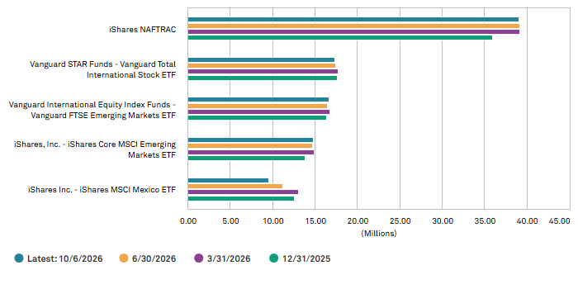

Inst. Owner Type

Owner Type

Type | Common Stock Equivalent Held | Institutional Ownership (%) | Percent of Common Shares Outstanding (%) | Market Value (Mex$M) | Number of Shareholders (actual)
Traditional Investment Managers | 228,768,215 | 96.92 | 5.32 | 12,676.0 | 87
Government Pension Sponsors | 5,958,189 | 2.52 | 0.14 | 330.1 | 4
Insurance Companies | 1,056,189 | 0.45 | 0.02 | 58.5 | 1
Sovereign Wealth Funds (<5% stake) | 167,294 | 0.07 | 0.00 | 9.3 | 1
Family Offices/Trusts | 89,686 | 0.04 | 0.00 | 5.0 | 1
Hedge Fund Managers (<5% stake) | 9,067 | 0.00 | 0.00 | 0.5 | 1
Total | 236,048,640 | 100.00 | 5.48 | 13,079.5 | 95

Institutional Ownership (%) by Owner Type

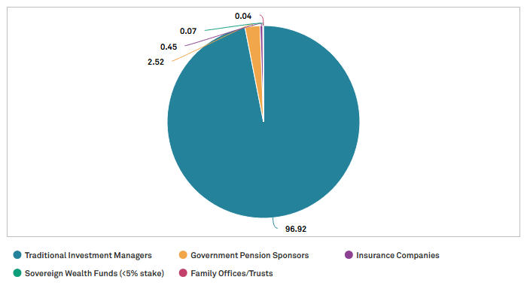

Country

Top Institutional Regional Holders

Country/Region | Number of Holders | Common Stock Equivalent Held | Percent of Common Shares Outstanding (%)
USA | 38 | 199,233,486 | 4.64
New York City, NY Metro | 16 | 114,821,912 | 2.67
Boston, MA Metro | 5 | 11,712,192 | 0.27
Austin, TX Metro | 1 | 11,755,209 | 0.27
San Francisco, CA Metro | 2 | 5,944,987 | 0.14
Chicago, IL Metro | 3 | 731,588 | 0.02
Kansas City, MO Metro | 1 | 727,757 | 0.02
Los Angeles, CA Metro | 2 | 1,071,410 | 0.02
Philadelphia, PA Metro | 2 | 666,346 | 0.02
Hartford, CT Metro | 1 | 22,600 | 0.00
Atlanta, GA Metro | 1 | 123,329 | 0.00
Seattle, WA Metro | 1 | 71,000 | 0.00
Other | 3 | 51,585,156 | 1.21
United Kingdom | 9 | 9,533,243 | 0.22
London, UK Metro | 6 | 6,014,619 | 0.14
Birmingham, UK Metro | 1 | 797,233 | 0.02
Scotland Metro | 1 | 252,284 | 0.01
Other | 1 | 2,469,107 | 0.05
Switzerland | 2 | 4,566,918 | 0.11
Zurich, Switzerland Metro | 1 | 4,118,618 | 0.10
Other | 1 | 448,300 | 0.01
France | 2 | 4,240,874 | 0.10
Paris/Ile-de-France Metro | 1 | 3,825,490 | 0.09
Other | 1 | 415,384 | 0.01
Mexico | 5 | 4,429,504 | 0.10
Mexico City Metro | 3 | 1,919,626 | 0.04
Other | 2 | 2,509,878 | 0.06

Percent of Common Shares Outstanding (%) by Country

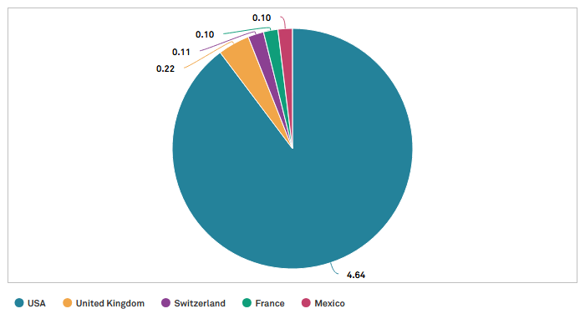

Style

Calculated Investment Style

Type | Common Stock Equivalent Held | Institutional Ownership (%) | Percent of Common Shares Outstanding (%) | Market Value (Mex$M) | Number of Shareholders (actual)
Growth | 235,366,142 | 99.71 | 5.48 | 13,041.6 | 85
Aggressive Growth | 513,279 | 0.22 | 0.01 | 28.4 | 4
GARP | 169,219 | 0.07 | 0.00 | 9.4 | 6
Total | 236,048,640 | 100.00 | 5.49 | 13,079.5 | 95

Institutional Ownership (%) by Style

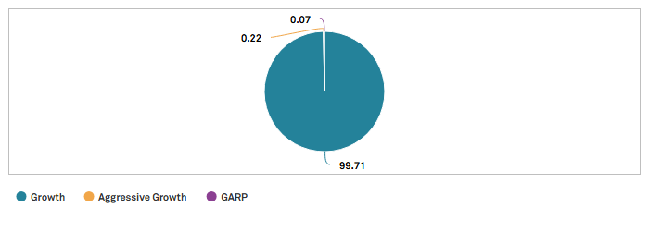

Market Cap

Market Cap Emphasis

Type | Common Stock Equivalent Held | Institutional Ownership (%) | Percent of Common Shares Outstanding (%) | Market Value (Mex$M) | Number of Shareholders (actual)
Large Cap | 235,895,964 | 99.94 | 5.49 | 13,071.0 | 92
Mid Cap | 119,626 | 0.05 | 0.00 | 6.6 | 2
Multi Cap | 33,050 | 0.01 | 0.00 | 1.8 | 1
Total | 236,048,640 | 100.00 | 5.49 | 13,079.5 | 95

Institutional Ownership (%) by Market Cap

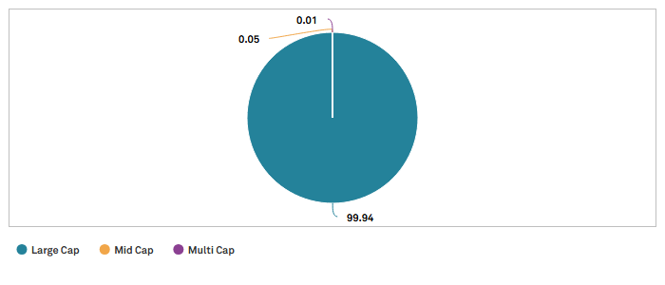

Turnover

Portfolio Turnover Ratio

Type | Common Stock Equivalent Held | Institutional Ownership (%) | Percent of Common Shares Outstanding (%) | Market Value (Mex$M) | Number of Shareholders (actual)
Very Low | 163,301,318 | 69.18 | 3.80 | 9,048.5 | 46
Low | 21,024,769 | 8.91 | 0.49 | 1,165.0 | 43
Moderate | 1,062,738 | 0.45 | 0.02 | 58.9 | 5
Unclassified | 50,659,815 | 21.46 | 1.18 | 2,807.1 | 4
Total | 236,048,640 | 100.00 | 5.49 | 13,079.5 | 98

Institutional Ownership (%) by Portfolio Turnover

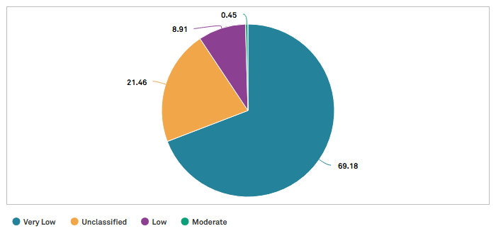

Top Buyers and Sellers

Top Buyers

Buyer | Common Stock Equivalent Held | Change in Shares | Position Date | Institution is an Activist?
Dimensional Fund Advisors LP | 11,755,209 | 496,544 | 8/31/2026 | No
American Century Investment Management Inc | 727,757 | 265,169 | 8/31/2026 | No
BlackRock Inc. | 104,120,971 | 238,701 | 9/30/2026 | No
Geode Capital Management LLC | 6,721,307 | 187,396 | 7/31/2026 | No
BMO Asset Management Corp. | 331,500 | 184,900 | 8/31/2026 | No

Top Sellers

Seller | Common Stock Equivalent Held | Change in Shares | Position Date | Institution is an Activist?
Impulsora Del Fondo Mexico SC | 1,800,000 | (315,448) | 7/31/2026 | No
Administradora General de Fondos Sura, S.A. | 0 | (37,973) | 10/5/2026 | No
Impulsora de Fondos Banamex S.A. de C.V. Sociedad Operadora de Sociedades de Inv | 19,626 | (36,704) | 6/29/2026 | No
Administradora General de Fondos Security SA | 0 | (36,359) | 6/30/2026 | No
Manulife Asset Management | 191,357 | (26,200) | 5/31/2026 | No

Ownership Activity

Institutions

Mar-31-2026 To Jun-30-2026 | Number of Holders | Common Stock Equivalent Held
Total Positions | 96 | 234,500,224
New Positions | 3 | 294,953
Increased Positions | 19 | 2,678,548
Decreased Positions | 20 | (10,066,904)
Sold Out Positions | 2 | (46,157)

Individuals/Insiders

No data matches your settings. Please edit your settings to display content.

Other Strategic Holders

No data matches your settings. Please edit your settings to display content.

Based on latest available data.
Public and Other equals total shares outstanding minus the sum of Institutions and all other Strategic Owners.
Reported Currency is the local currency of the equity listing, and currency conversion is based on today’s spot rate.
Shares Held includes positions from 13F filings plus data aggregated from the mutual funds of non-13F filers. Excludes any positions held by non-US mutual funds managed by 13F filers.
Total Shares Outstanding can exceed 100% because reporting requirements for holdings data is not aligned with the financials reporting of shares outstanding.
Market value is calculated using the closing price 55.41 MXN as of 10/6/2026.

